The Book of Vaughan

A Summary of the Photoglottography Project (March 2024 - Feb 2025)

Primary Author: yours truly, [Vaughan Altmann](mailto:valtmann@ucsd.edu)

Major Contributors: Deepta Bharadwaj, Isabelle Villegas, and Erica Yang

Mentors: Dr. Marc Garellek and Dr. Will Styler

Institution: University of California, San Diego

# Outline

Glossary

Background

Failures

Testing Protocol

Current Models

General Schematic

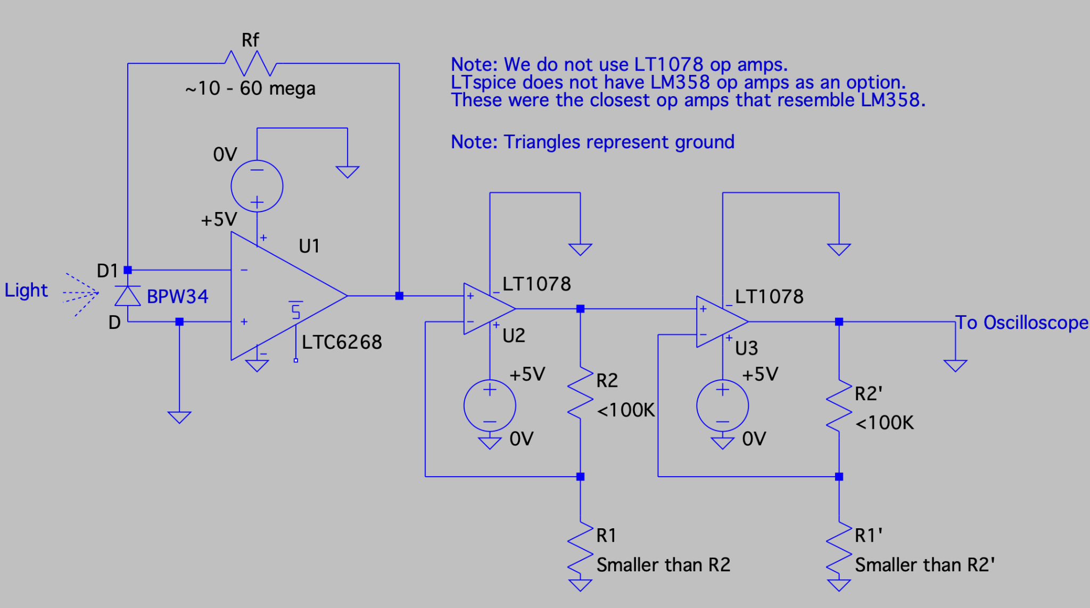

<https://www.ti.com/lit/an/sloa011b/sloa011b.pdf?ts=1737461624504>

# Glossary (in Vaughan’s terms)

Voltage - The “pressure”, from an electrical circuit's power source “that pushes” charged electrons (current) . For this project, it indicates the strength of the signal.

Current - The rate of flow (“speed”), of the electrons. Generally unimportant for op amps, except for the input for a transimpedance amplifier.

OpAmp - an integrated circuit (IC) that amplifies the voltage difference between two inputs.

Transimpedance Amplifier - A set up of an opamp and resistor to turn a current source into a voltage source.

Supply Voltage (Vs) - the electrical voltage that powers a circuit or device. It's also known as source voltage.

Op Amp Quiescent Current (Is) - The amount of current an op amp supply terminal will take from your voltage source in order to operate. The opamp will take what current it needs from a power source.

Differential Input Voltage - The difference between the +/- input terminals. Maximum Differential Input Voltage is what the Op Amp vendor states as the max.

Gain Bandwidth Product - Gain Bandwidth Product is a figure of merit calculated by multiplying the amplifier's bandwidth and the gain at which the bandwidth is measured. Generally the higher the better.

Input Bias Current (IB) - The average amount of current That flows into or out of the op amp input terminals.Also called input leakage current.

Output Current (Io) - Max current out from an opamp. Usually not an issue since most opamps work in voltages.

Slew Rate - How quickly an opamp reacts to change in a signal. Generally not going to be an issue for this project since we are working in the audio range.

Diode - A semiconductor device with two terminals, allowing the flow of current in one direction only.

Photodiode - A semiconductor that allows more current flow with the presence of light, aka a sensor. We use photodiodes as the sensors for this project.

Reverse Bias - when a voltage is applied to a semiconductor diode in a way that opposes the natural flow of current. Doing this to a photodiode increases its sensitivity to light (good). Forward bias (inverse of reverse bias, duh) does not increase the sensitivity of a photodiode, so don’t do that.

# Background: Amplification Steps

Opamps are great devices for amplifying signals. This is due to their design. That’s the most you’re gonna get out of me. I’m not a writer, so you’ll now see example circuit designs and their amplification equation.

Inverting Amplifier

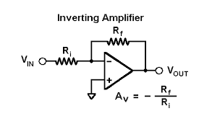

The signal’s voltage will be amplified and converted to the opposite sign of the original signal. The higher Rf is or the smaller Ri is, the greater the gain. Rf stands for feedback resistor, aka the resistor creating gain. The gain can be fractional in this form, so you can DECREASE a signal’s voltage with this configuration. NOTE: if your signal*gain > supply voltage (of that sign +/-), your signal will flatline at that rail. An opamp can provide infinite gain in theory, however, the supply voltages are the main limiter of this.

Non-Inverting Amplifier:

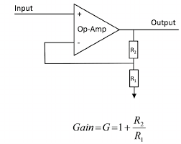

Similar to the earlier amplifier, however, there is no sign inversion. Interestingly, the gain always increases the magnitude of the signal, unlike the inverting amp. Here, R2 is the feedback resistor.

NOTE: If your feedback loop goes from output to + terminal (for this configuration, - terminal for inverting amp), you have created a comparator! That circuit will be useless for the current parameters for this project, so don’t do that.

Transimpedance Amplifier

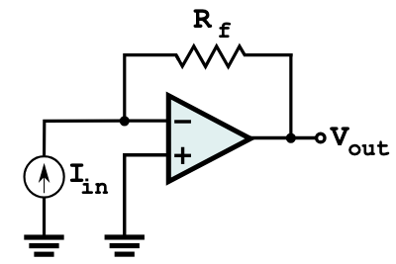

Vaughan, you may want to provide the equation for this circuit; i.e. Vout = - RF * In. The output will be negative if the photodiode output current is like that shown in the diagram. Turn the diode (current source) around if you want a positive output voltage.

The Vout is directly proportional to Rf and Iin, Vout = Rf * Iin. The greater the Rf, the greater the magnification. Remember that the input voltages limit the output (if output would’ve been 5V but you only have a positive rail of 3V, you’ll get 3V).

Since photodiodes operate like a current source, we cannot use the normal amplifying a voltage method. Hence, the transimpedance amplifier. This step is essential so we can have a voltage signal for the later amplification steps.

Op amps selected for transimpedance amplifiers should have an input bias current much smaller than the output current of the photodiode. We are using the LTC6268 for this function. Transimpedance amplifiers have very low input bias current (current lost or “eaten” by op amp) and have a small power supply window (LTC6268 has a range of ~5V). If you need a different op amp for this function, please look up other transimpedance amplifiers.

Keep in mind that the + input to ground is called the reference voltage. If there was a +2.5V at the point, the output would oscillate around 2.5V inside of 0V.

BPW34 (photodiode) Polarity

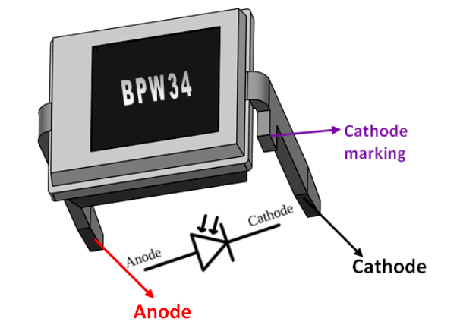

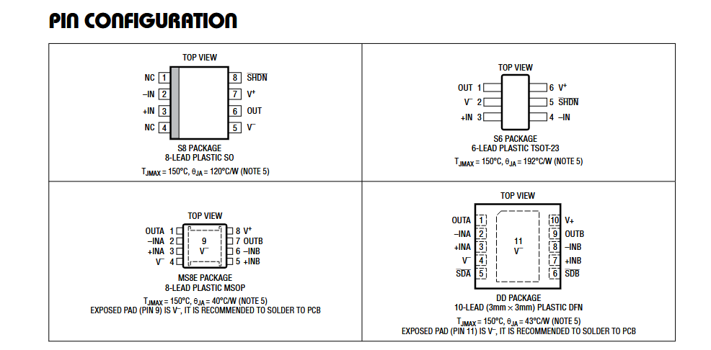

# Failures

We have gone through a lot of iterations. Here are the ones that did not pan out.

Utilizing a LM358 as a transimpedance amplifier. Did not work at all. Likely due to it having a high input bias current, eating most of the signal from the photodiode.

Reverse biasing the photodiode. It should work in theory, however, we did not find major differences in outputs. Also very difficult to achieve without multiple power sources. Should revisit.

Implementing adjustable resistors. Due to 2 major issues: adjustable resistors tend to be bulky (originally obtained to have an adjustable transimpedance step) and are not meant to be adjusted constantly. Their adjustments are not precise. Maybe we could utilize smaller, more easily implemented ones for the subsequent amplification steps.

Vaughan, you may want to suggest a value for Rf here

“Poof” capacitors. Literature indicated that we could use capacitors within the picofarad (pF) range. Did not have much success with them. David (DIB lab manager) indicated that it was likely due to them being too small and becoming saturated with charge too quickly for the voltages we are working with. Best to use capacitors in the micro to nanofarad range.

Implementing a bandpass filter with only one LM358. Would be very efficient for power management, however, constantly fails due to misplaced resistor locations and powering. Has worked effectively before but needs constant surveillance. Ideally we move the filtering to a lock-in amplifier instead.

# Old Breadboard

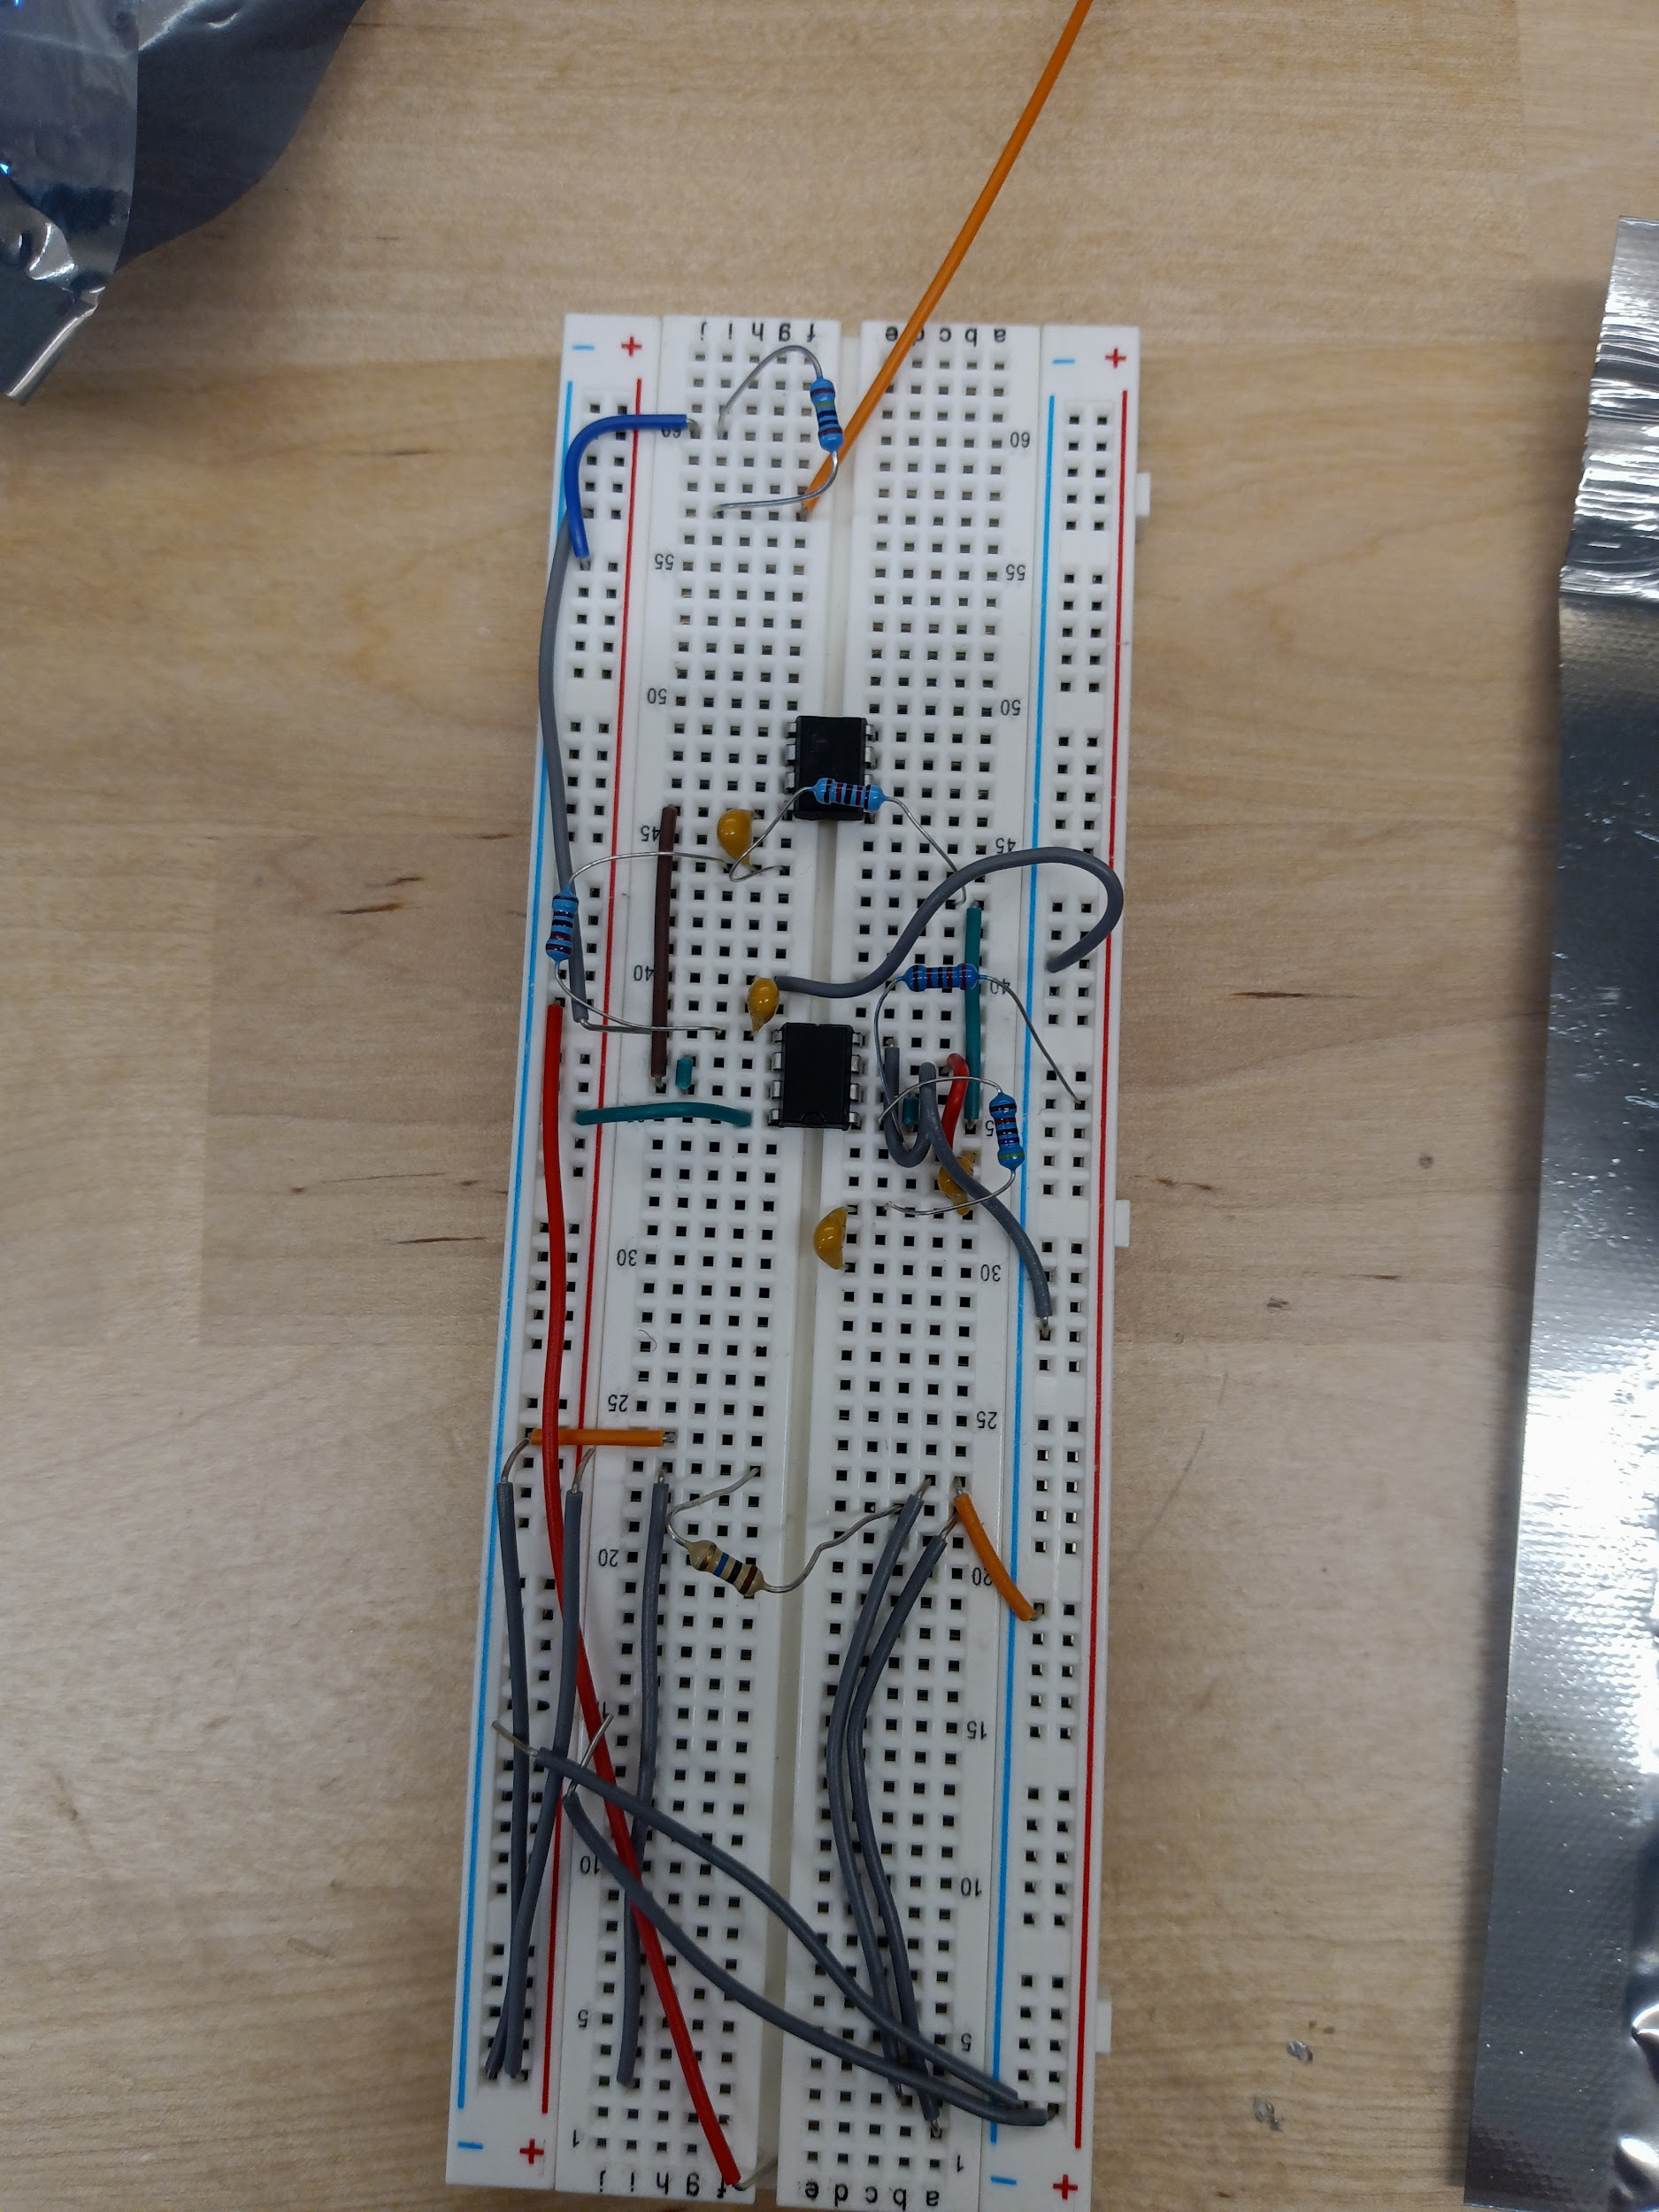

Not conducive to needs of project; Still have it bc in theory if we ever think can be reworked we’d still can use it

DO NOT USE

# Set Up/Testing Protocol

**Transimpedance Stage**

Set up the power supply (do not turn on the voltage yet) and oscilloscope. We need at least a 5V power supply for the transimpedance amplifier.

Connect the power supply to the transimpedance amplifier. Make sure the +5V is on the + rail to the LTC6268 and the ground is on the - rail. The cathode of the BPW34 photodiode should connect to the - signal input and the anode to ground. Once all of that is achieved, connect the output from the op amp and ground to the oscilloscope. Turn on the power supply. If in a light room, the signal should jump up from zero. If you place your finger on top of the sensor, it should return to zero.

**Potential Problems**

If the amplification is too high, you can lower the Rf. Please have the power supply off when making changes to the circuit.

If you are not getting a reading, that means the output wire is in the wrong place, or you are not powering the device correctly. Turn off the power supply and recheck the wire inserts.

If you are getting a negative reading, the photodiode is likely backwards or not connected to ground. Check photodiode placement (do not need to turn off power for this one since the sensor is not connected to the power supply).

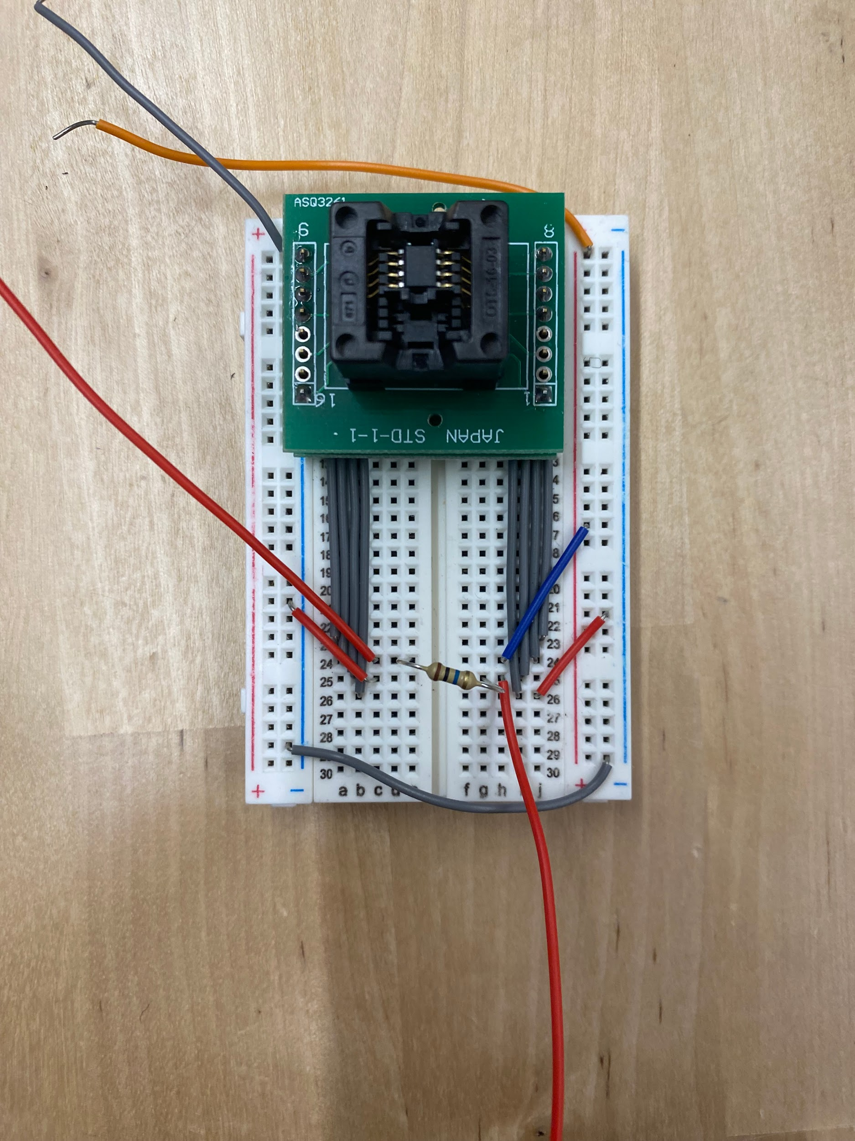

The green complex contains the LTC6268 op amp. Descending grey wires are op amp terminals 1-4 from left to right on the left side, and 5-8 from left to right on the right side. Red input wire (spans from top left to pin 2 (- input)) represents where the cathode end of the photodiode sensor would go. The anode end of the sensor would go into the ground or a negative potential rail. A 10M ohm resistor (Rf) connects pin 2 to pin 6, the output (amplified signal comes from here). Pins 3 and 5 are connected to ground (little red wires), pin 7 is connected to +5V supply (blue wire). The top grey wire supplies the right negative rail. The right negative rail connects pin 5 to ground (0V) from the power source (via a little red wire on the right side). The top orange wire supplies the positive rail and would connect to +5V from the power source. Grey bottom wire connects the two negative rails of the output so pin 3 is connected to ground.

**Secondary amplification stage (double non-inverting)**

Turn the power off of the power supply and disconnect it from the transimpedance amplifier if it was connected.

Set up a sine wave signal with a signal generator. Make it in the mV range (<200 mV), and centered around zero (no offset). We will attach it to the amplification stage momentarily.

Apply the 5V power supply (or any voltage you plan on using) to the LM358 to the correct terminals. Since LM358s are dual op amps, we only need one set of power supply for two stage amplification. Make sure that Vout1 goes into the + input2.

Attach oscilloscope to ground and Vout2. Apply the sine wave signal to + input1 and turn on power supply. You should see a stronger signal out!

**Potential Problems**

If you see no signal, that means there is a connection issue with Vout1 -> + input2 or that you are not reading from Vout2. Turn off the power and check the circuit.

If you see a signal but with no amplification, there is an error with powering. Turn off the power and check the power rail connections.

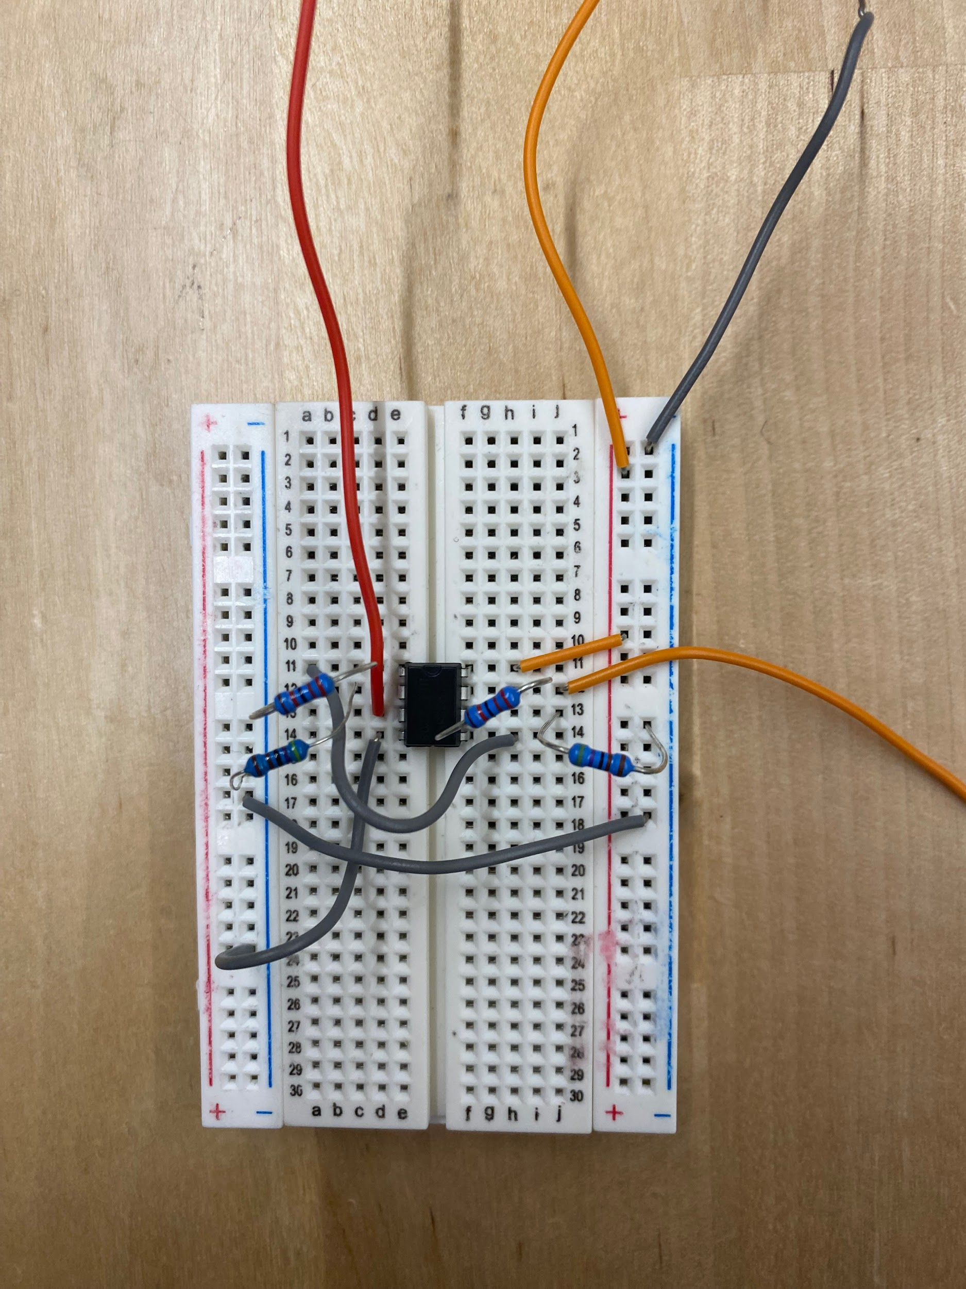

The small black box is the LM358 op amp. Red input wire (spans from top left to pin 3 (+ input)) represents the connection from output from transimpedance to the second stage amplifier. Pin 4 is connected to ground. Pin 2 (- input) has R2 (Rf effective) and R1 coming from it. R2’ connects pin 6 to pin 7 (output2) while R1’ connects pin 6 to ground. The grey wire coming from pin 1 connects to the pin 5 (+ input2). Similar to pin 2, pin 6 (- input2) has R2’ (Rf’ effective) and R1’ coming from it. R2’ connects pin 6 to pin 7 (output) while R1’ connects pin 6 to ground. The top grey wire (left) supplies the negative rail and would connect to ground (0V) from the power source/transimpedance amplifier stage. The top orange wire supplies the positive rail and would connect to +5V from the power source//transimpedance amplifier stage. There is a grey wire towards the bottom that connects the two negative rails of the output so pin 4 is connected to ground.

**Transimpedance Stage + Secondary amplification stage (double non-inverting)**

Turn the power off of the power supply and disconnect it from the second stage amplifier if it was connected.

Connect the power lines from the transimpedance stage to the secondary stage amplifier if they are receiving the same amount of power. If the second stage is utilizing more than 5V, do not do this step.

Connect the output from the transimpedance amplifier to input1 on the second stage amplifier. Make sure that Vout1 goes into the + input2. Attach oscilloscope to ground and Vout2. Turn on the power.

You should see a maxed out signal from the device in normal lighting conditions. The signal should return close to zero when pressed against skin. Due to the very high gain, the baseline may not be at zero volts. This is normal (although problematic) since the sensor will always produce a little bit of electrical noise, which is amplified.

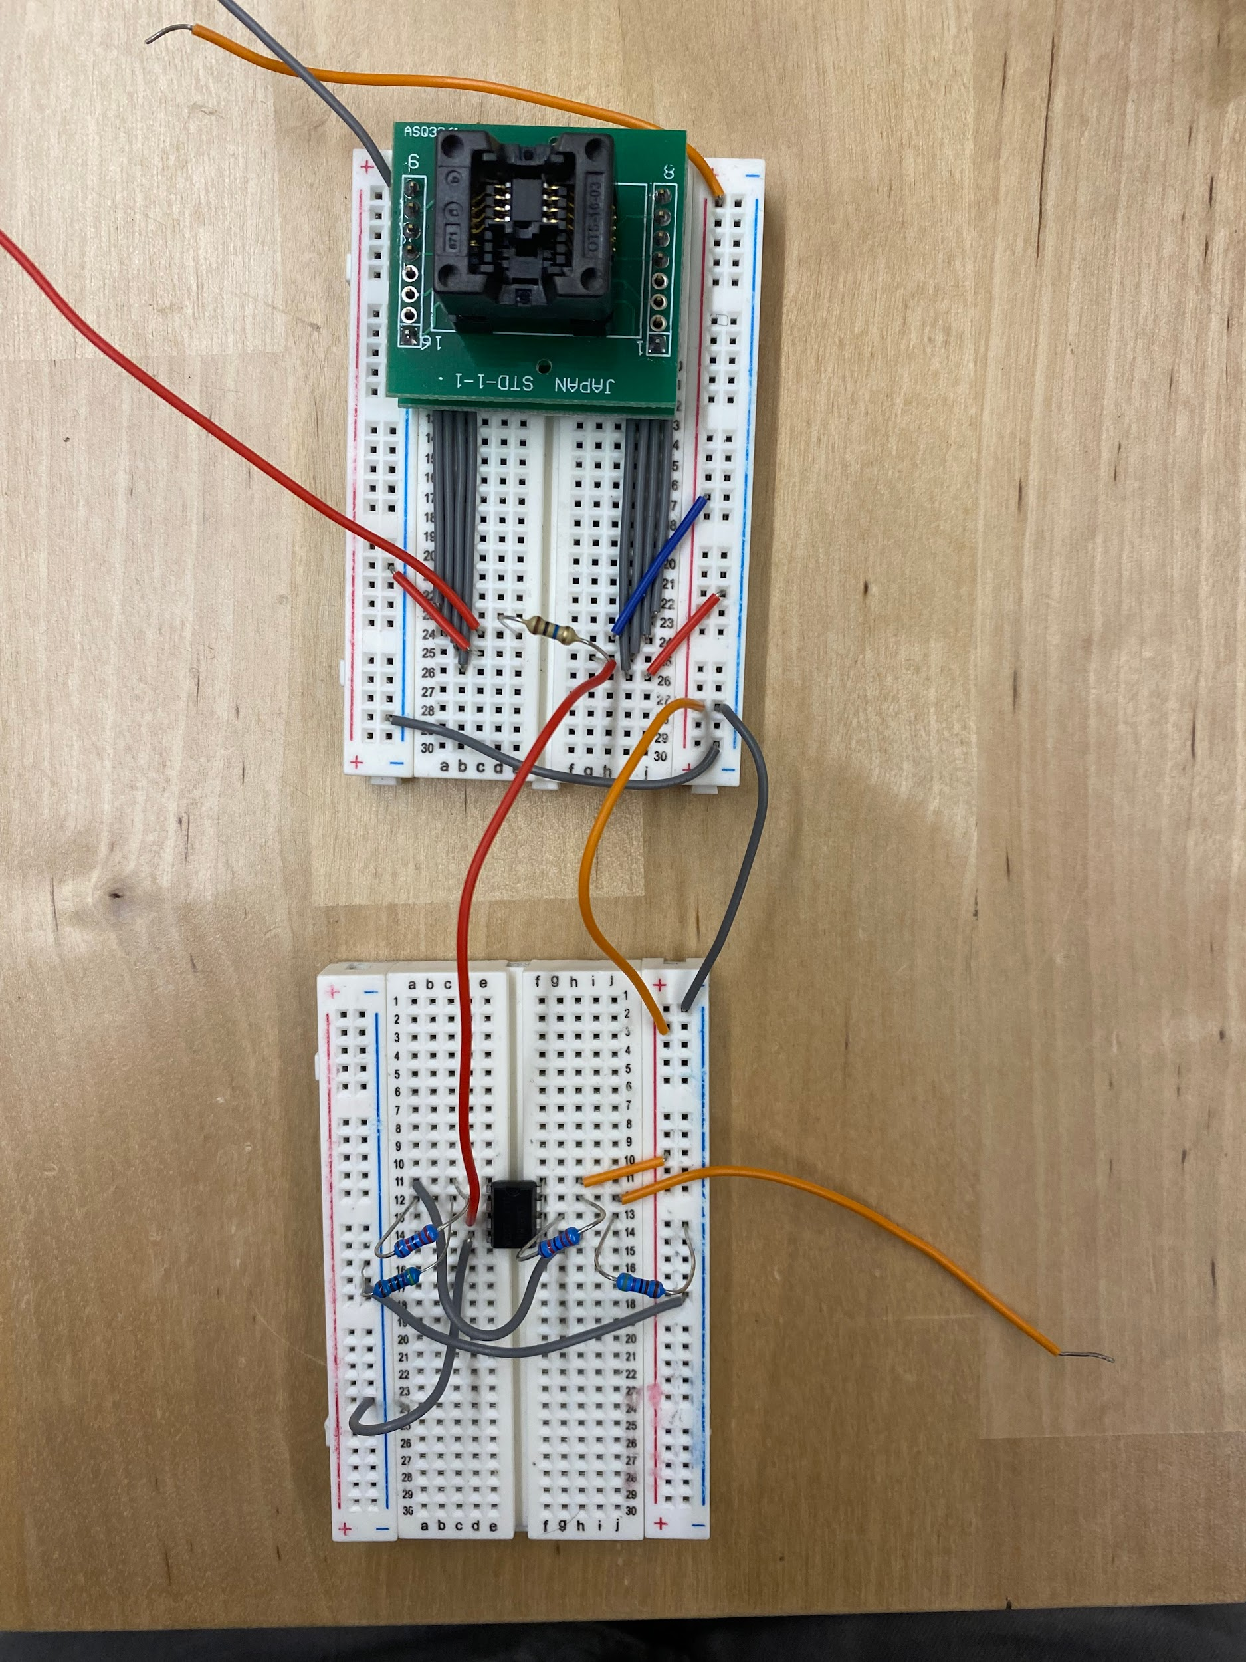

Output from transimpedance (red wire connecting the breadboards) connects to pin 3 (+ input) of second stage amplifier (LM358). Middle orange wire connects the +5V power supply of both breadboards. Middle grey wire connects the - power supply or ground of both breadboards. Top orange and grey wires connect to the power source described in the transimpedance step.

**Potential Problems**

If the baseline is too high (above 20% of max volt output), you have too much gain. To remedy the gain issue, lower the Rf values for either the transimpedance or 2nd amp step.

If the sensor is not being insulated from outside light well enough, you can have a high baseline as well. Make sure the sensor is pressed against the skin well enough and cover the sensor during testing.

If you get no voltage out after connecting the two amplification steps together, recheck the wires connecting the two. Repeat the first two checks for each stage if necessary.

If you get no voltage in the set up after switching out a resistor or component, make sure no resistors/wires are touching anything they should not be touching and that nothing has been knocked out of place.

If the signal out is not being amplified as much as expected, you may have some resistor values off. If the signal is not being amplified further during the 2nd stage, even though it does amplify weak voltage signals, you are not giving enough voltage to the second stage amplifier. Only increase the power only if the transimpedance stage alone can reach max amplification of signals that are passing through a hand or arm.

Remember, more gain does not necessarily mean better data retrieved. The goal is to be more SENSITIVE and have readable measurements from signals through the throat. Increasing gain generally increases the readability of changes, not the sensitivity.

Current Schematic: Jan 30th, 2025

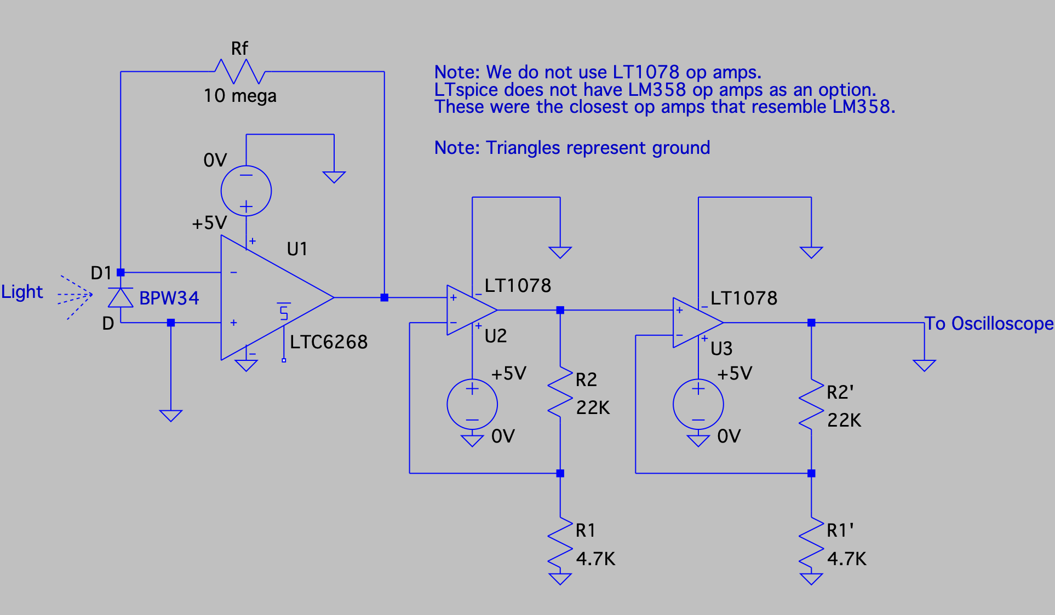

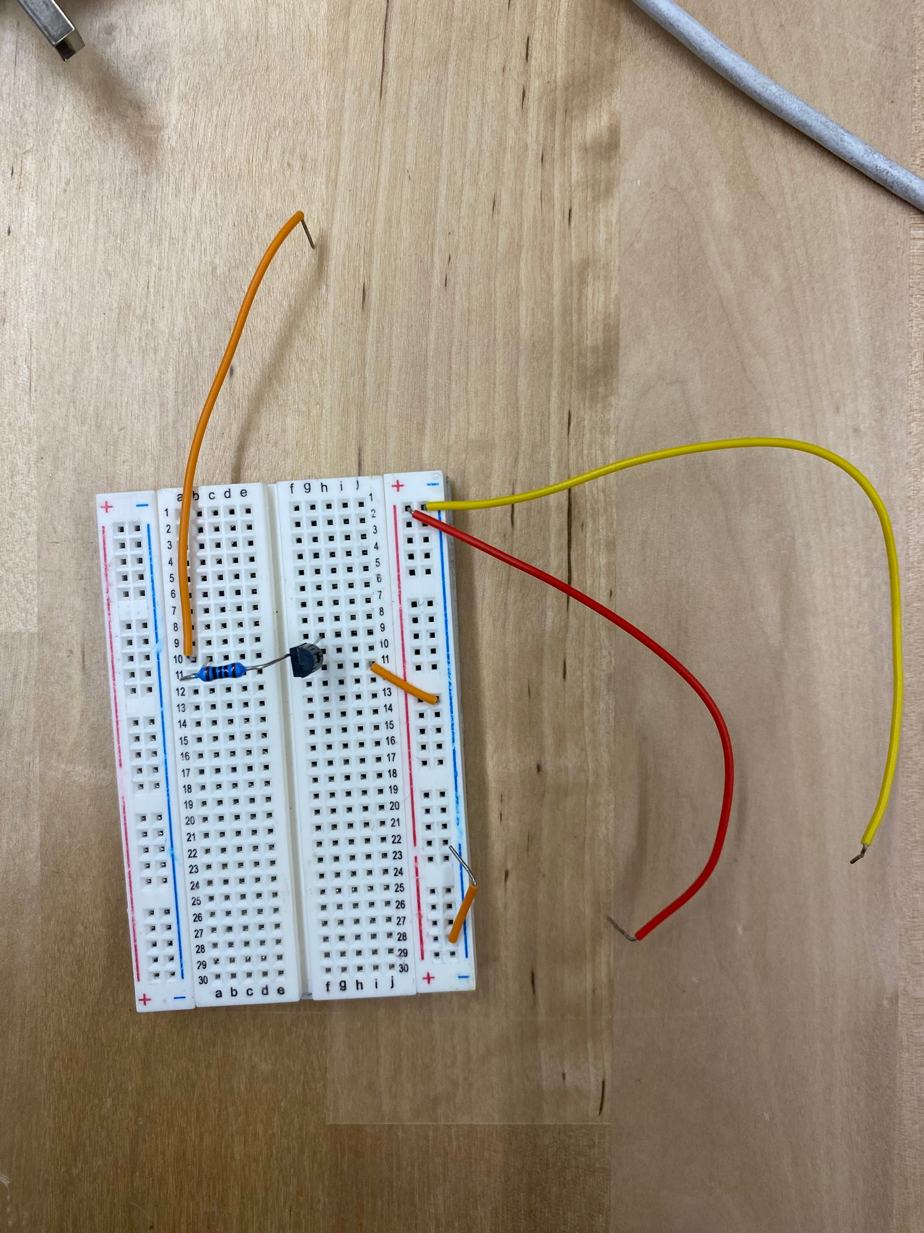

Transistor for light modulation set up. Red wire = + power supply, yellow wire = - power supply/ground. Input from the orange through the resistor allows more current to flow into the lights, making them brighter. Lights would be connected at line 9 and + power supply rail.